**Assignment Unit V**

**Part-A**

1 Which of the following code create a n item vector of random normal deviates?

a) x1 &lt;- c(snorm(n))

b) x1 &lt;- c(pnorm(n))

c) x1 &lt;- c(rnorm(n))

d) x1 &gt;- c(norm(n))

Q.2 ___________ remove all the variables from the workspace.

a) rm(x)

b) rm(list=ls())

d) attach(mat)

Q.3 JSON is a _____ for storing and transporting data.

a) xml format

b) text format

c) JavaScript

d) php format

Q.4 Which of the following is the plotting character?

a) Sch

b) Pch

c) Grd

d) Pck

Q.5 JSON stands for _______.

a) JavaScript Object Notation

b) Java Object Notation

c) JavaScript Object Normalization

d) JavaScript Object-Oriented Notation

Q.6 Every ________ function has a probability distribution function.

a) Continuous

b) Discrete

c) Categorical

d) Random

Q.7 How many types of tags are there in an XML document?

a) 3

b) 4

c) 5

d) 6

Q.8 Summary of the data frame provide values like

a)Mean

bMedian

C)1st Quartile

D) Mode

Q.9 JSON strings have to be in

a)single quote

b) double quote

c)single quote or double quote

d)None of the above

Q.10 In the JSON syntax, data is in ____ pairs.

a) class/object

b) name/value

c) datatype/variable

d) value/=

Q.11 Which answer represents the following order of TYPES? Object, String, Boolean, Number

a) “{ }”, “a string”, “false”, “0”

b) [ ], 0, “true”, “0”

c) { }, “0”, false, 0

d) { }, hello, “false”, “0”

Q.12 ____is used to read XML documents and provide access to their content and structure.

a) XML Processor

b) XML Pre-processor

c) XML Compiler

d) XML Interpreter

Q.13 Suppose you want to simulate a coin toss 20 times in R. Write the command.

a) resample(c(&quot;H&quot;, &quot;T&quot;), 20, replace=T)

b) sample(c(&quot;H&quot;, &quot;T&quot;), 20, replace=T)

c) sample((&quot;H&quot;, &quot;T&quot;), 20, replace=T)

d) sample(c(&quot;H&quot;, &quot;T&quot;), 200, replace=T)

Q.14 Axes, axis labels and titles all appear in the ________ of the figure.

a) Directions

b) Margin labels

c) Margins

d) Widths

Q.15 Which of the following is not a function of csv module?

a) readline()

b) writerow()

c) reader()

d) writer()

Q.16 Which of the following parameter needs to be added with open function to avoid blank row

followed file each row in CSV file?

a) qoutechar

b) quoting

c) newline

d) skiprow

Q.17 CSV Stands for?

a) compact serial values

b)common standard values

c)control space values

d)comma separated values

Q.18 Elemantary commands in R consists of either ______________ or assignments.

a)utilstats

b)langauge

c)Expresssions

d)Packages

Q.19 All individuals rows of CSV files are called

a)Tuple

b)Data

c)Record

d)Cardinality

Q.20 A common use of JSON is ________.

a) to update data into the database

b) to retrieve data from the database

c) to exchange data to/from a web server

d) None of the above

**Part-B 5X2=10**

Q.1 How to read and analyze XML file?

Ans we **can quickly open it in a text editor, web browser, XML viewer, or even Microsoft Excel**

Q.2 How to read and analyze JSON file?

Ans

1. We import the json package with an import statement.
2. We have chosen to use the with statement to open the SAFI. json file. ...
3. 'json_data' is the file handle.
4. The json. ...
5. The variable d is a list of dictionaries. ...
6. The json.

Q.3 How to read and analyze Binary file?

Ans

1. file. The file command will help you identify the exact file type that you are dealing with. ...
2. ldd. ldd prints the shared objects (shared libraries) required by each program or shared object specified on the command line. ...
3. hexdump. ...
4. 4 readelf. ...
5. objdump.

Q.4 How to read and analyze text file?

Ans **Use the ReadAllText method of the My.** **Computer.** **FileSystem object to read the contents of a text file into a string, supplying the path**.

Q.5 Distinguish between getwd() and setwd().

**The getwd R function returns the filepath of the current working directory.** **The setwd R function specifies a new working directory**.

**Part-C**

Q.1 Define Data Interfaces. How it works with R.

Ans

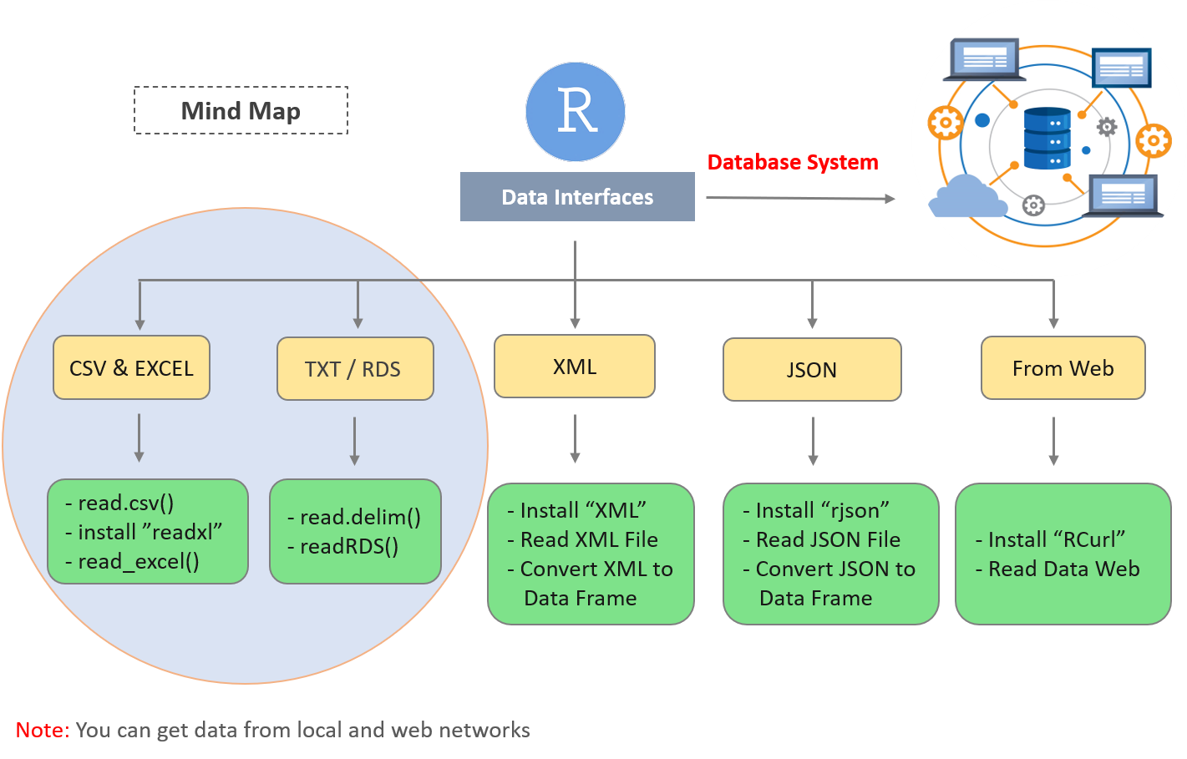

Q.2 How to create, save and read excel file?

**Open a new, blank workbook**

1. Click the File tab.
2. Click New.
3. Under Available Templates, double-click Blank Workbook. Keyboard shortcut To quickly create a new, blank workbook, you can also press CTRL+N.

**Save your workbook**

1. Click File > Save As.
2. Under Save As, pick the place where you want to save your workbook. ...
3. Click Browse to find the location you want in your Documents folder. ...
4. In the File name box, enter a name for a new workbook. ...
5. To save your workbook in a different file format (like . ...
6. Click Save.
7. Step 1: Install the readxl package. In the R Console, type the following command to install the readxl package: install.packages("readxl") ...
8. Step 2: Prepare your Excel File. Let's suppose that you have an Excel file with some data about products: ...
9. Step 3: Import the Excel file into R.

Q.3 How to analyze XML files? Explain step by step.

Ans XML which stands for Extensible Markup Language is made up of markup tags, wherein each tag illustrates the information carried by the particular attribute in the XML file. We can work with the XML files using the XML package provided by [R](https://www.geeksforgeeks.org/introduction-to-r-programming-language/).

#### Creating XML file

XML files can be created by saving the data with the respective tags containing information about the content and saving it with ‘.xml’.  
We will use the following XML file ‘sample.xml’ to see the various operations that can be performed on the file:

#### Reading XML File

The XML file can be read after installing the package and then parsing it with **xmlparse()** function, which takes as input the XML file name and prints the content of the file in the form of a list. The file should be located in the current working directory. An additional package named ‘methods’ should also be installed. The following code can be used to read the contents of the file “sample.xml”.

Q.4 Write a R script to read file and retrieve the maximum salary.

Ans

data <- read.csv("input.csv")

# Get the max salary from data frame.

sal <- max(data$salary)

print(sal)

Q.5 Write a R script to read CSV file (emp.csv) and retrieve the employee names of IT department.

Ans # Create a data frame.

data <- read.csv("input.csv")

retval <- subset( data, dept == "IT")

print(retval)

**Part-D 2X10=20**

Matrix

# Q.1 How to read xml and JSON file? Explain how to select specific rows and columns in R?

Ans

install.packages("rjson")

# Load the package required to read JSON files.

library("rjson")

# Give the input file name to the function.

result <- fromJSON(file = "input.json")

# Print the result.

print(result)

# Load the package required to read JSON files.

library("rjson")

# Give the input file name to the function.

result <- fromJSON(file = "input.json")

# Convert JSON file to a data frame.

json_data_frame <- as.data.frame(result)

print(json_data_frame)

# All Rows and All Columns

df[,]

# First row and all columns

df[1,]

# First two rows and all columns

df[1:2,]

# First and third row and all columns

df[ c(1,3), ]

# First Row and 2nd and third column

df[1, 2:3]

# First, Second Row and Second and Third COlumn

df[1:2, 2:3]

# Just First Column with All rows

df[, 1]

# First and Third Column with All rows

df[,c(1,3)]

Q.2. Write a R script to read CSV file (stu.csv) and retrieve the marks of those students whose marks is greater than 80%.

Ans

csv_data <**-** read.csv(file **=** 'stu.csv')

print(csv_data)

>marks <- max(data$Marks.Scored) #this will give you the highest marks

#To extract the details of a student who scored the highest marks,

> data <- read.csv("traindata.csv")

> Marks <- max(data$Marks.Scored)

> retval <- subset(data, Marks.Scored == max(Marks.Scored)) #This will

extract the details of the student who secured highest marks

> View(retval)